Biodiversity and water quality at Alren Farm

An event for the community at the hub of the Stoke Climsland Farm cluster
Saturday 24th June 11-2pm
This Lottery-funded Farm Net Zero event will take place at the Alren Farm, Stoke Climsland, PL17 8PT. Please meet at the farm (What3words:///averts.warblers.remodel).
Pasties will be provided so please book a place (email below)
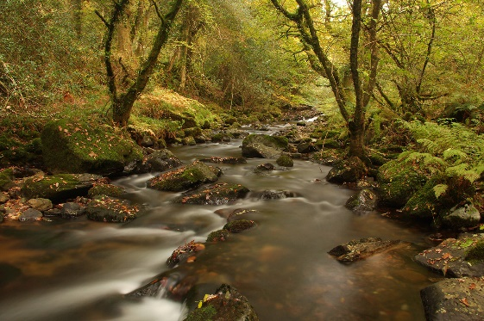
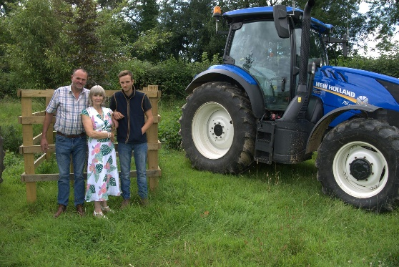

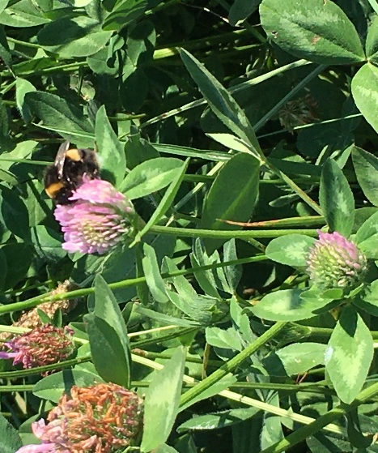

Bonny Lightfoot of Alren farm has been one of the farmers central to building the award winning 21-strong Stoke Climsland Farm Cluster. Bonny, Tim and Jake are holding an event to discuss what they are doing to improve water quality and support biodiversity.
Other speakers include:
- Robin Jackson (Duchy College) Director of the Rural Business School
- James Harbord (Westcountry Rivers Trust)
- James Coumbe (Westcountry Rivers Trust) Land Adviser, and Farm Cluster Coordinator
- Hannah Jones (Farm Carbon Toolkit) Soil quality and carbon adviser

The Defra Funding will support innovations by the Lightfoots and others in the farm cluster to enhance the beautiful environment of the Stoke Climsland Parish.

To book your place, contact:
Alex Bebbington (alex.bebbington@duchy.ac.uk), James Harbord (jamesh@wrt.org.uk); Hannah Jones (Hannah.jones@farmcarbontoolkit.org.uk)

